Introduction to WebLogic Server
- Owned by: Oracle Corporation
- Type: Java EE Application Server (supports Servlet, JSP, EJB, JMS, JPA, etc.)
- Use Case: Enterprise deployment platform for Java-based applications.

WebLogic Architecture Overview
- Domain: A logically related group of WebLogic Server resources.
- Admin Server: Central control entity of a domain (only one per domain).
- Managed Server: Hosts actual apps and resources.
- Node Manager: Utility to control server instances remotely.
- Cluster: Group of managed servers for load balancing & failover.
- Machine: A logical representation of the physical computer (used with Node Manager).

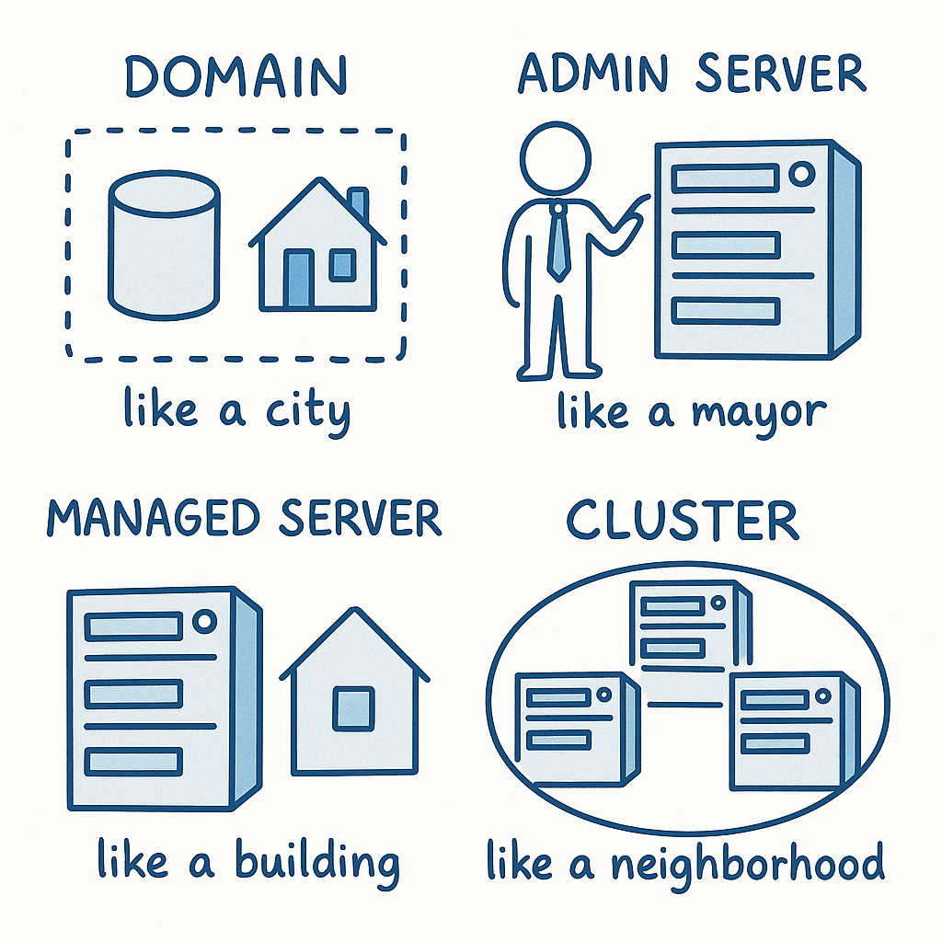

🔷 1. Domain

💡 Real-life Analogy: A Housing Society
Imagine a gated housing society:
- All buildings, security, gardens, electricity, and residents are part of one society.
- It is managed as one logical unit.
🔍 In WebLogic:
- A Domain is like that society.
- It contains everything: Admin Server, Managed Servers, configurations, deployments, etc.
- It's the highest-level structure in WebLogic.

🔷 2. Admin Server

💡 Real-life Analogy: Society Office / RWA President
In your housing society:
- The society office (or Resident Welfare Association head) keeps full control.
- Handles all administration: security, maintenance, new resident entries, etc.
🔍 In WebLogic:
- The Admin Server is the control center of the domain.
- It manages configurations, deployments, and controls all Managed Servers.
- There's always only one Admin Server in a domain.

🔷 3. Managed Server

💡 Real-life Analogy: Individual Residential Buildings
Each building in the society:
- Has its own rooms (flats) where people live.
- Some have gyms, some have shops.
🔍 In WebLogic:
- A Managed Server is where your actual applications run (like websites, APIs).
- You can have many managed servers.
- Admin Server controls them, but does not run applications itself (in most cases).

🔷 4. Node Manager

💡 Real-life Analogy: Remote Watchman with Master Keys
Say each building has a watchman who can remotely open or close any building or flat:
- Can start/stop electricity remotely.
- Keeps track of status and reports to society office.
🔍 In WebLogic:
- Node Manager is a utility that starts/stops Admin or Managed Servers remotely.
- Helps in automated restarts, health monitoring, etc.
- Installed on each machine (server box) to control servers on that machine.

🔷 5. Cluster

💡 Real-life Analogy: Multiple Buildings with Same Facilities
Imagine 3 buildings in the same society:
- All have gyms and shops.
- If gym in building A is full, you go to B or C.
🔍 In WebLogic:
- A Cluster is a group of Managed Servers doing the same job.
- Used for Load Balancing (spread users across servers).
- And for Failover (if one fails, others take over).
Example: If 10,000 users hit your website, the load is split across all servers in the cluster.

🔷 6. Machine

💡 Real-life Analogy: Physical Plots in the Society
Every building (Managed Server) stands on some land/plot.
That plot is a physical entity.
🔍 In WebLogic:
- A Machine represents the physical or virtual hardware.
- Used mostly with Node Manager to say: “This server runs on this machine.”

✅ Summary Table for Quick Revision
WebLogic Term | Real-Life Analogy | Role in WebLogic
Domain | Housing Society | Logical group of all WebLogic resources
Admin Server | Society Office / President | Central controller of the domain
Managed Server | Individual Residential Buildings | Hosts and runs the real applications
Node Manager | Remote Watchman with Master Keys | Starts/stops servers remotely
Cluster | Similar Buildings with Same Facilities | Group of managed servers for load balancing/failover
Machine | Physical Plot or Land | Represents hardware where server runs

==================== WebLogic Architecture ====================
+------------------+
| DOMAIN | <-- Like a Housing Society
|------------------|
| Admin Server | <-- Like Society Office / President
| (Control Panel) |
+--------+---------+
|
---------------------------------------------
| |
+-------------------+ +-------------------+
| Managed Server 1 | <-- Like Building 1 | [Runs App A] |
+-------------------+ +-------------------+
| |
+-------------------+ +-------------------+
| Managed Server 2 | <-- Like Building 2 | [Runs App B] |
+-------------------+ +-------------------+
| |
+-------------------+ +-------------------+
| Managed Server 3 | <-- Like Building 3 | [Runs App A] |
+-------------------+ +-------------------+

CLUSTER
(Managed Servers grouped together for
Load Balancing & High Availability)
-------------------------------------------------------------
NODE MANAGER
(Remote Watchman to Start/Stop Servers on Each Machine)

Machine A -------------> Controls Admin + MS1
Machine B -------------> Controls MS2
Machine C -------------> Controls MS3

==============================================================

WebLogic Administrator

🔹 Introduction
What is Oracle WebLogic Server 14c?
Oracle WebLogic Server 14c is a modern Java EE-compatible application server and the runtime foundation for Oracle Fusion Middleware, supporting enterprise applications, microservices, cloud-native deployments, and more.

Editions in 14c:
- Standard Edition (SE): For developers and small-scale deployments.
- Enterprise Edition (EE): SE + clustering + advanced diagnostics.
- WebLogic Suite: EE + Coherence + TopLink + enhanced scalability.

🔹 Key Concepts in WebLogic 14c

🔸 WebLogic Server Instance
- A JVM process that hosts your Java EE applications.
- Two types:
  - Admin Server: Central controller.
  - Managed Server: Runs business applications.

🔸 WebLogic Domain
- A logical container that includes:
  - 1 Admin Server
  - N Managed Servers
  - Services (JDBC, JMS, etc.)
  - Machines and optional clusters

🔸 Admin Server
- Special WebLogic instance for configuration and monitoring.
- Hosts the Admin Console (web-based GUI at http://localhost:7001/console).
- Should not host applications in production.

🔸 Managed Server
- Hosts deployed applications and their related resources (JDBC, JTA, JMS).
- Contacts Admin Server on startup to sync config.
- Can run independently after starting (MSI mode).

🔸 Cluster
- A group of Managed Servers with:
  - Same app deployed
  - Shared configuration
- Enables load balancing and failover.
- Often used with a hardware or software load balancer.

🔸 Node Manager
- A separate process used to remotely start/stop servers.
- Must be configured per machine.
- Used in combination with Admin Console or WLST.
- Two types: Java-based (cross-platform) and Script-based (Unix-only).

🔸 Machine
- A logical representation of a host machine (physical/VM).
- Required for using Node Manager and for clustering configuration.

Weblogic dir structure

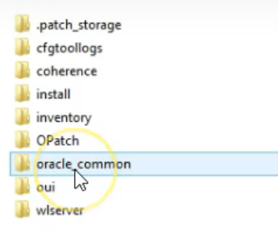

- coherence (core Coherence product files)
• install (files related to installation run)
• inventory (product inventory that is local to this Oracle home)
• OPatch (patch and update tool)
• oracle_common (libraries required by WebLogic Server)
• oraInst.loc (pointer to local inventory)
• oui (installer tool product files)
• wlserver (core WebLogic Server product files)

📁 1. .patch_storage
- Purpose: Stores history of applied patches (used by OPatch).
- Analogy: Like a medical record file showing which surgeries (patches) were done and when.
- Example: If you apply WebLogic Patch p123456, its metadata is stored here to allow rollback or audit.

📁 2. cfgtOollogs
- Purpose: Stores logs from configuration tools like config.cmd.
- Analogy: Think of it as the "receipt bin" — all logs of what you did during domain creation.
- Example: When you run domain configuration wizard, logs are saved here for troubleshooting.

📁 3. coherence
- Purpose: Contains Oracle Coherence libraries and configs.
- Analogy: Like a RAM-based distributed filing cabinet used to share data across servers.
- Example: If WebLogic uses in-memory caching, it loads Coherence jars and settings from here.

📁 4. install
- Purpose: Metadata and XMLs about the WebLogic installation.
- Analogy: Like a receipt + instruction sheet for what components got installed.
- Example: Oracle tools read this to know what version of WebLogic or Coherence is present.

📁 5. inventory
- Purpose: Stores the Oracle Central Inventory files.
- Analogy: Like a pantry index for all Oracle software on the system.
- Example: During patching or upgrades, Oracle reads from here to check versions & components.

📁 6. OPatch
- Purpose: Contains the Oracle patching tool (opatch.bat, libraries).
- Analogy: Like a toolbox for fixing bugs in WebLogic.
- Example: Run opatch lsinventory from here to see applied patches.

📁 7. oracle_common
- Purpose: Shared Java libraries & utilities across all Oracle products (like JRF).
- Analogy: Like a shared kitchen used by many tenants (products like WebLogic, SOA, OBIEE).
- Example: JRF templates, EM (Enterprise Manager), MDS common jars are here.

📁 8. oui (Oracle Universal Installer)
- Purpose: Contains the installer engine, scripts, logs.
- Analogy: Like the installation wizard’s brain & memory.
- Example: When installing WebLogic silently or via GUI, it’s driven by OUI stored here.

📁 9. wlserver
- Purpose: Contains the actual WebLogic Server runtime and libraries.
- Analogy: This is the heart of WebLogic — includes everything needed to start and run servers.
- Subfolders:
  - server/ → core server classes and scripts
  - common/ → domain templates
  - lib/ → jars like weblogic.jar, webservices.jar
- Example: When you start WebLogic using startWebLogic.cmd, it pulls runtime from wlserver.

🧠 Summary (Table Format)
Folder Name | Role | Analogy
.patch_storage | Patch history store | Medical record of system patches
cfgtOollogs | Logs from configuration tools | Receipt bin from setup wizard
coherence | In-memory grid runtime | Shared RAM cache
install | Install metadata | Software install receipt
inventory | Oracle inventory database | Pantry catalog
OPatch | Patching toolkit | Screwdriver for fixing bugs
oracle_common | Shared libraries for Oracle stack | Shared kitchen for apps
oui | Installer engine | Wizard's brain
wlserver | WebLogic server runtime | Engine of the whole application

installation was failing for weblogic 12c on office laptop but while i change location of these folder it worked

🔍 Root Cause: TMP / TEMP Directory Permissions
From your screenshot:
ini
CopyEdit
TMP = C:\Users\busyc\AppData\Local\Temp
WL_HOME = C:\Weblogic\wlserver
On many corporate machines, the AppData\Local\Temp folder is restricted, or:
- Disk quotas are enforced
- Long path names cause issues
- Files in Temp are deleted or blocked by antivirus
- Installer cannot write or extract required files there

✅ Why Changing the Temp Folder Worked
When you changed the TEMP and TMP variables to a custom path like:
makefile
CopyEdit
C:\WebLogicTemp
...you bypassed the permission/length/antivirus issues, allowing the installer to:
- Extract files successfully
- Run bundled Java/JARs from a safe location
- Complete patching and copying files

🛠️ Recommended Fix (Permanent)

1. Set Temporary Directory Manually
Before running java -jar fmw_12.2.1.x_wls.jar:
cmd
CopyEdit
set TEMP=C:\WebLogicTemp
set TMP=C:\WebLogicTemp
OR
Create a batch file:
bat
CopyEdit
@echo off
set TEMP=C:\WebLogicTemp
set TMP=C:\WebLogicTemp
java -jar fmw_12.2.1.4.0_wls.jar

🧠 Summary (Trainer Tip)
Always use a custom TEMP directory with full permissions (e.g., C:\WLTemp) when installing WebLogic on restricted environments like office laptops, VMs, or domain-joined systems

